DATA MANAGEMENT ACCOUNTING GROUP PROJECT

Team 1: Lewis Brown, Aaditya Diwan, Mowalola Onigbanjo, Jo-En Chang

Data Management & SQL

Group Project

Due: 4/11/2021

Introduction:

From the designated accounting database, we were instructed to build queries to insert financial data from an unknown corporation in order to perform a financial review. The queries built reflect the financial data in the form of Profit and Loss and Balance Sheet statements. MY SQL Workbench was utilized to normalize and sort the data, retrieving only relevant data to create tables to output the desired financial documents. This report provides details regarding the execution of the project objectives, our team interaction, and the key learnings behind the management of the dataset to produce the final output of the project.

Project Execution/SQL Script:

The SQL script which was created to extract the financial data from the H_Accounting database is provided below. The first SQL script provides a constructed Profit and Loss statement from the H_Accounting database given for the project. The script following the Profit and Loss statement provides the Balance Sheet statement. When running the SQL scripts below in Workbench, tables are provided detailing the financial data for this company. A stored procedure was utilized in the Balance Sheet statement which allows the user to select the desired fiscal year, to provide the Balance Sheet statement for that year. The desired fiscal year must be entered into the code prior to running it to produce the desired Balance Sheet for the specified year.

Profit and Loss statement SQL script:

USE H_Accounting;

DROP PROCEDURE IF EXISTS `adiwan2019_sp`;

DELIMITER $$

CREATE PROCEDURE `adiwan2019_sp`(varCalendarYear YEAR)

BEGIN

-- We receive as an argument the year for which we will calculate the balance sheet

-- This value is stored as an 'YEAR' type in the variable `varCalendarYear`

-- The procedure name will have to be changed to that of a new user, should another user run the code,

-- as only the admin has rights view stored procedures for all user --

SELECT statement_section_order, statement_section_code, statement_section,

FORMAT(SUM((CASE WHEN YEAR(je.entry_date) = varCalendarYear THEN

(CASE WHEN ss.debit_is_positive = 0 THEN jel.credit ELSE jel.credit * -1 END)

ELSE 0 END)),2) AS Amount

FROM journal_entry_line_item AS jel

INNER JOIN account AS ac ON ac.account_id = jel.account_id

INNER JOIN journal_entry AS je ON je.journal_entry_id = jel.journal_entry_id

INNER JOIN statement_section AS ss ON ss.statement_section_id = ac.profit_loss_section_id

WHERE ac.profit_loss_section_id <> 0

AND debit_credit_balanced <> 0

AND cancelled = 0

AND YEAR(je.entry_date) = varCalendarYear

GROUP BY statement_section_id;

END $$

DELIMITER ;

CALL adiwan2019_sp(2017);

Balance Sheet statement SQL script:

USE H_Accounting;

DROP PROCEDURE IF EXISTS `monigbanjo2020_sp`;

DELIMITER $$

CREATE PROCEDURE `monigbanjo2020_sp`(varCalendarYear YEAR)

BEGIN

-- We receive as an argument the year for which we will calculate the balance sheet

-- This value is stored as an 'YEAR' type in the variable `varCalendarYear`

-- The procedure name will have to be changed to that of a new user, should another user run the code,

-- as only the admin has rights view stored procedures for all user --

SELECT statement_section_code, statement_section,

FORMAT(SUM(IFNULL(debit, 0)), 0) AS DEBIT,

FORMAT(SUM(IFNULL(credit, 0)), 0) AS CREDIT,

FORMAT(SUM(DEBIT) - SUM(CREDIT),0) AS Total

FROM journal_entry_line_item AS jel

INNER JOIN account AS ac ON ac.account_id = jel.account_id

INNER JOIN statement_section AS ss ON ss.statement_section_id = ac.balance_sheet_section_id

INNER JOIN journal_entry AS je on je.journal_entry_id = jel.journal_entry_id

WHERE balance_sheet_section_id <> 0

AND ss.statement_section_code IN ('CA', 'FA', 'DA', 'CL', 'LLL', 'DL', 'EQ')

AND debit_credit_balanced <> 0

AND YEAR(je.entry_date) <= varCalendarYear

AND je.cancelled = 0

AND is_balance_sheet_section = 1

GROUP BY statement_section_id

ORDER BY statement_section_id;

END $$

DELIMITER ;

CALL monigbanjo2020_sp(2017);

Profit and Loss statement illustration:

Balance Sheet statement illustration:

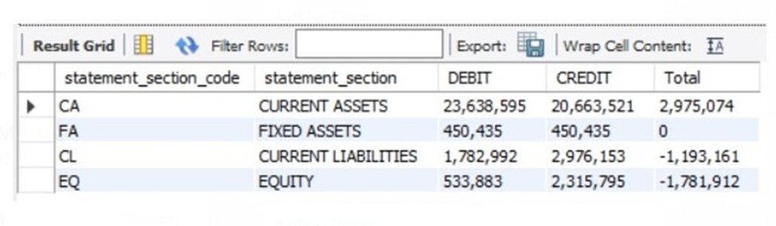

Team Interaction:

Our team consisted of four members: Lewis Brown, Aaditya Diwan, Mowalola Onigbanjo, and Jo-En Chang. When dividing the duties for this project, the team was divided into two subset teams. Each of these teams was assigned a statement to create the accompanied script. Lewis Brown and Mowalola Onigbanjo worked together to create the script for the Balance Sheet statement and Aaditya Diwan and Jo-En Chang collaborated together to create the script for the Profit and Loss statement. Both statement scripts were combined to create the content for this project. Mowalola Onigbanjo played a vital leadership role is overseeing and managing the entire SQL script for the project, making corrections and edits when necessary to produce final scripts that provide the desired statements. Lewis Brown played a vital role in managing the team from start to completion for this specific project, as well as writing the reflection paper for final submission. Aaditya Diwan and Jo-En Chang played vital support roles in completion of the project from start to finish. The team dynamic was productive, and each member of the team made contributions to the project in preparation for the final submission.

Key Learnings and Takeaways:

In execution of this project, many skills and key learning were produced during this process. Skills regarding data management, creation of queries and tables, and writing code in SQL to retrieve the desired data from a large dataset are amongst the most significant key learnings and takeaways from completing this project. If given the opportunity to complete this project again under the same time constraints, there are a few things that would have been completed differently. One main factor that would have changed and made management of the dataset easier is that we would have cleaned and normalized the dataset prior to beginning the management process extracting various information to create Profit and Loss and Balance Sheet statements.

Conclusion:

This was a challenging dataset to manage for completion of the project. Throughout the process, vital skills were developed that will benefit the members of this team in the future. Once we were able to explore the data and had a clear vision on how to achieve the objective of the project, we were able to execute all tasks productively.